Isango Product Overview

Contents

1.0. Introduction 3

1.1. Purpose 3

1.2. Scope 3

1.3. Overall Description 3

2.0 Basic Functionality 4

2.1. Home Page. 4

2.2. Search Stack Page 7

2.3. Search Results Page 9

2.4. Product Detail Page 10

2.4. Product Availability Page 12

2.5. Cart Page 13

2.6. Payment Page 14

2.7. Confirmation Page. 16

3.0 Type of Products available on Isango 18

4.0 Supporting Information 18

Revision History

|  |  |  |  |
| --- | --- | --- | --- |
| **Date** | **Version** | **Description** | **Author** |
| 06/15/2015 | 1.0 | Product Overview | QA Team |
| 06/19/2015 | 1.1 | Product Overview | QA Team |
|  |  |  |  |
|  |  |  |  |

# 1.0. Introduction

## 1.1. Purpose

The purpose of this document is to present a broad overview of the Web based holiday activities booking system. It will explain the purpose and features of the system, the interfaces of the system, what the system will do, the constraints under which it must operate and how the system will react to external stimuli. This document is intended for providing a high level insight of the system.

## 1.2. Scope

## 1.3. Overall Description

Isango is a specialist retailer of tours, experiences and attraction tickets. Through our award-winning website - isango.com we allow consumers to research and book all their holiday activities online [www.isango.com](http://www.isango.com/) is the flagship website of Isango! Limited. Isango! Limited manage and operate a range of brands including Love Orlando Tickets, Just London Theatre Breaks and Paris Magic Moments as well as destination specialist sites such as Local Paris Tours. In 2013 Isango! Limited served customers in more than 150 countries. Isango! Limited is part of the TUI Travel PLC group of companies.

We, like you, are travelers who have come to expect that the online sites ought to offer much more than telling us what the best price is to get from A to B, or giving us a list of hotels in a particular city. There have got to be sites like that but we think that online travel should move to the next level. We believe we travel to do things, find out about cultures, people, and places and see what the world has to offer. First, to tell you all about a destination - the stuff you need to know to understand a place, and have a complete view of the experiences you can find over there. Then, to bring those products together under one roof for you to plan and book in the most convenient way.

# 2.0 Basic Functionality

This section provide a bird eye view about how web application works. Below mentioned are the basic pages user encounter while using the website.

* Home Page.
* Search Stack Page
* Search Result Page.
* Product Detail Page.
* Product Availability Page.
* Cart Page.
* Payment Page.
* Confirmation Page.

## 2.1. Home Page.

* Application display home page when user launch Isango Home page URL ([www.isango.com](http://www.isango.com)).

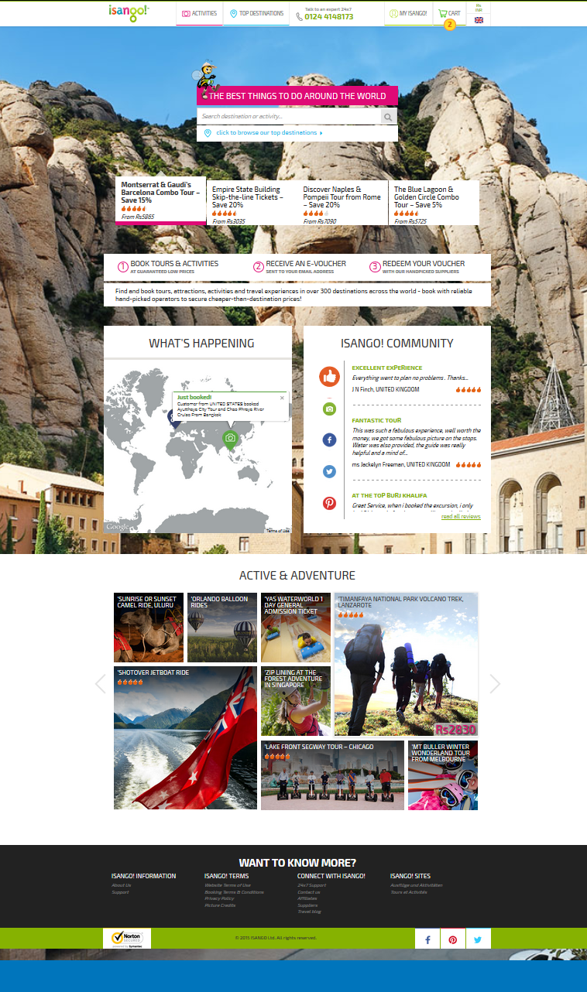

* Home page have following below mentioned sections:

1. Header
2. Search area
3. Hero Merchandise module
4. module
5. What’s Happening
6. Isango! Community
7. Top Sellers
8. Footer

* Application allows user to perform search using destination or activity’s name.
* User can collect more information about product and how it works using links display in footer.
* Application has feature of ip-2-location which enables website to display currency of region from where it is launched.
* Application allows user to change product price currency. Below mentioned are the available current on website:

1. AUD
2. CAD
3. EUR
4. GBP
5. HKD
6. INR
7. SGD
8. USD

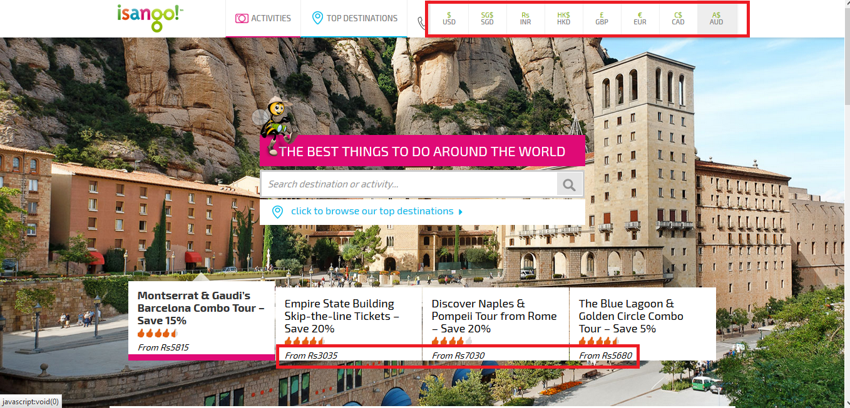

## 2.2. Search Stack Page

* Search stack page comes only when user searches for a destination which has multiple categories like Food and wine, Classes and workshops, Shopping etc.
* It comes when user searches destination like Paris, Amsterdam etc.
* Sections displays on this page are:

1. Must-do
2. Top Attractions
3. Browse by Category
4. See all Tours and Activities in <<Search Key>>. (To see all products)

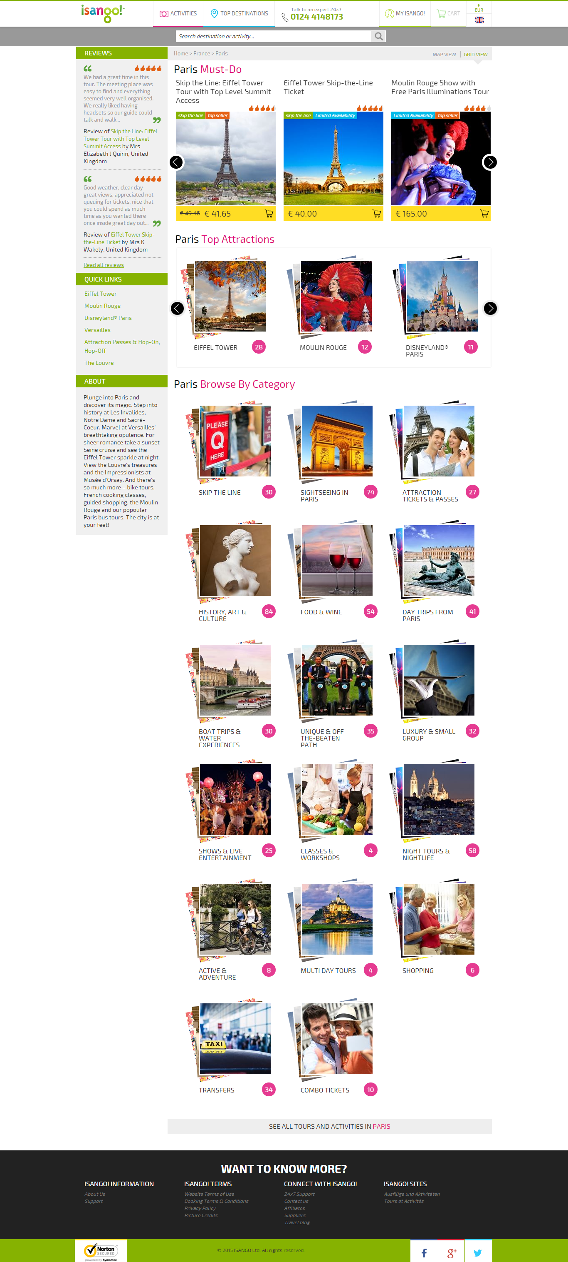

## 2.3. Search Results Page

* This page appears when user searches a destination for which we have limited number of products in database.
* This page shows all the associated products as per searched term.
* Products are not tagged to any category like search stack page.
* It comes when user searches destinations like Spain, Africa.

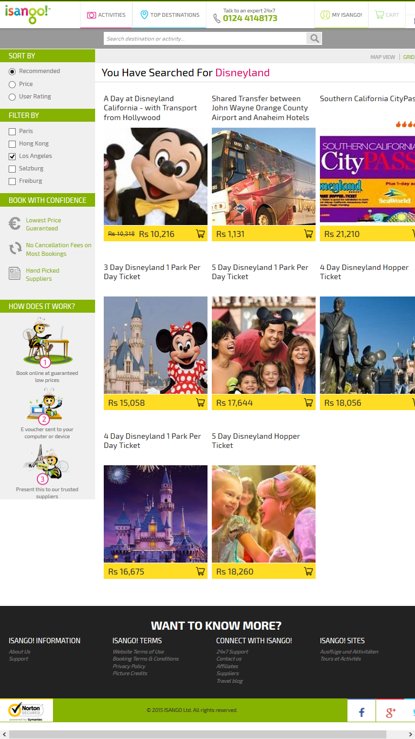

* Application displays filters as per search results.
* Application display additional information and review.
* User also can change the search result view:

1. Map view
2. Grid View

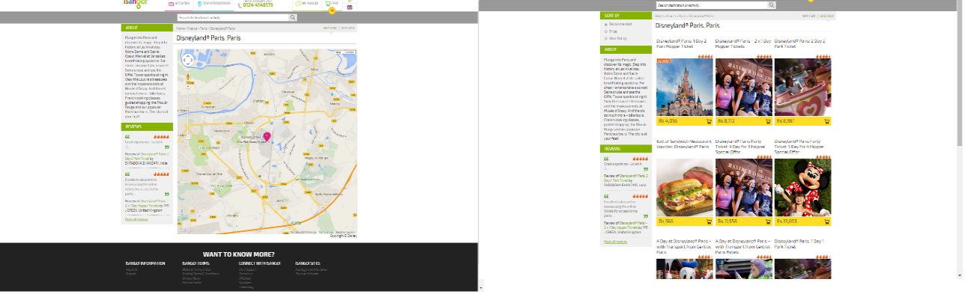

## 2.4. Product Detail Page

* Application displays product page when user click on product available on search result page:

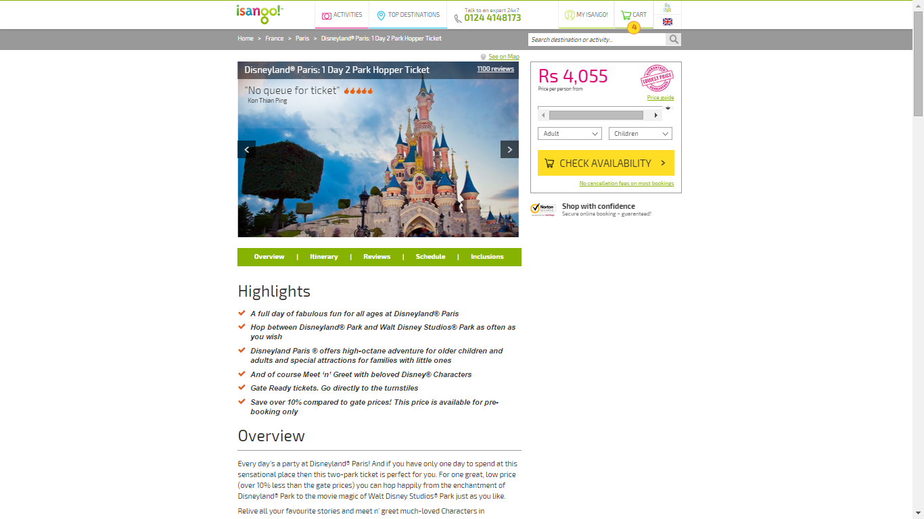

* Application displays sections on page:

1. Highlights
2. Overview
3. Itinerary
4. Reviews
5. Schedule
6. Inclusions
7. Check Availability Module

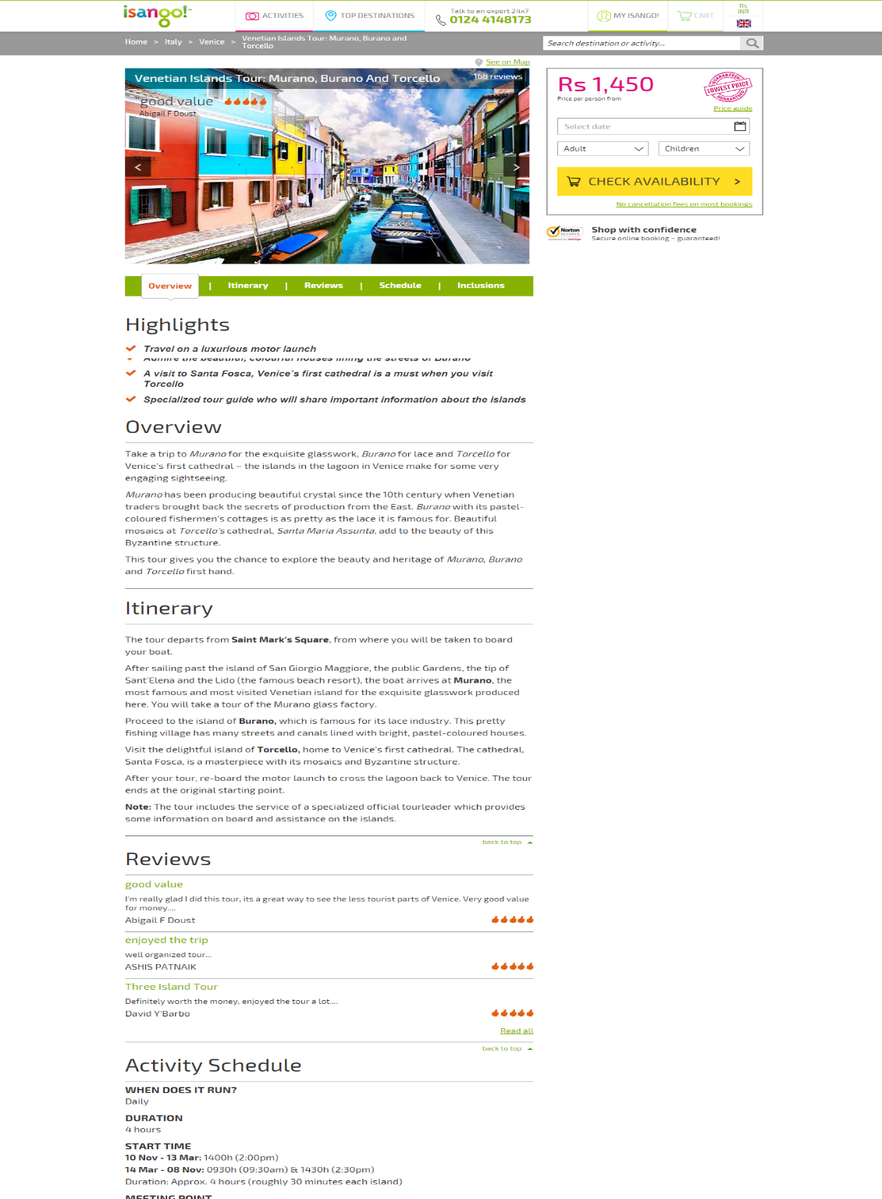

* Application displays number of child age dropdown on basis of number of children’s selected

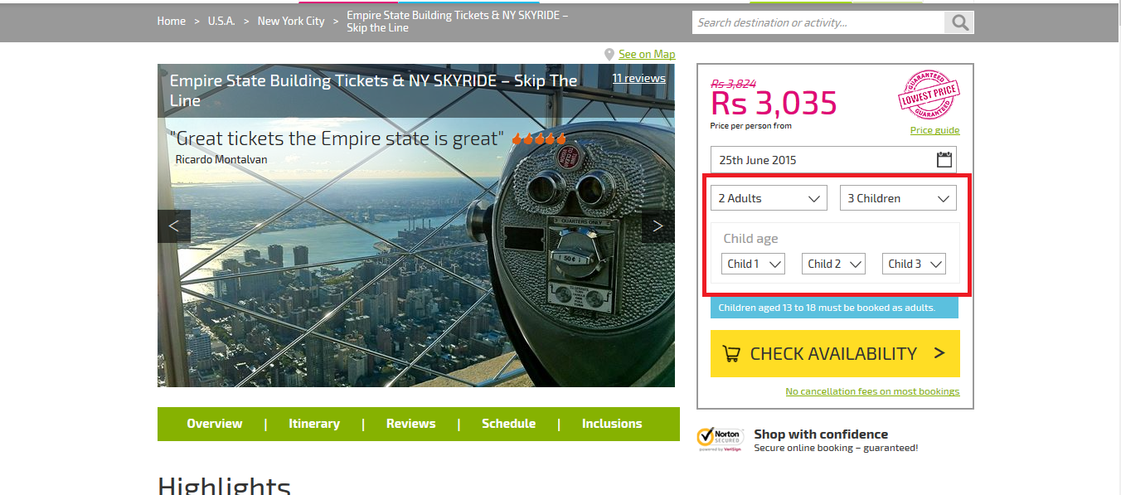

## 2.4. Product Availability Page

* Application displays product availability page when user click on “Check Availability” from product detail page.

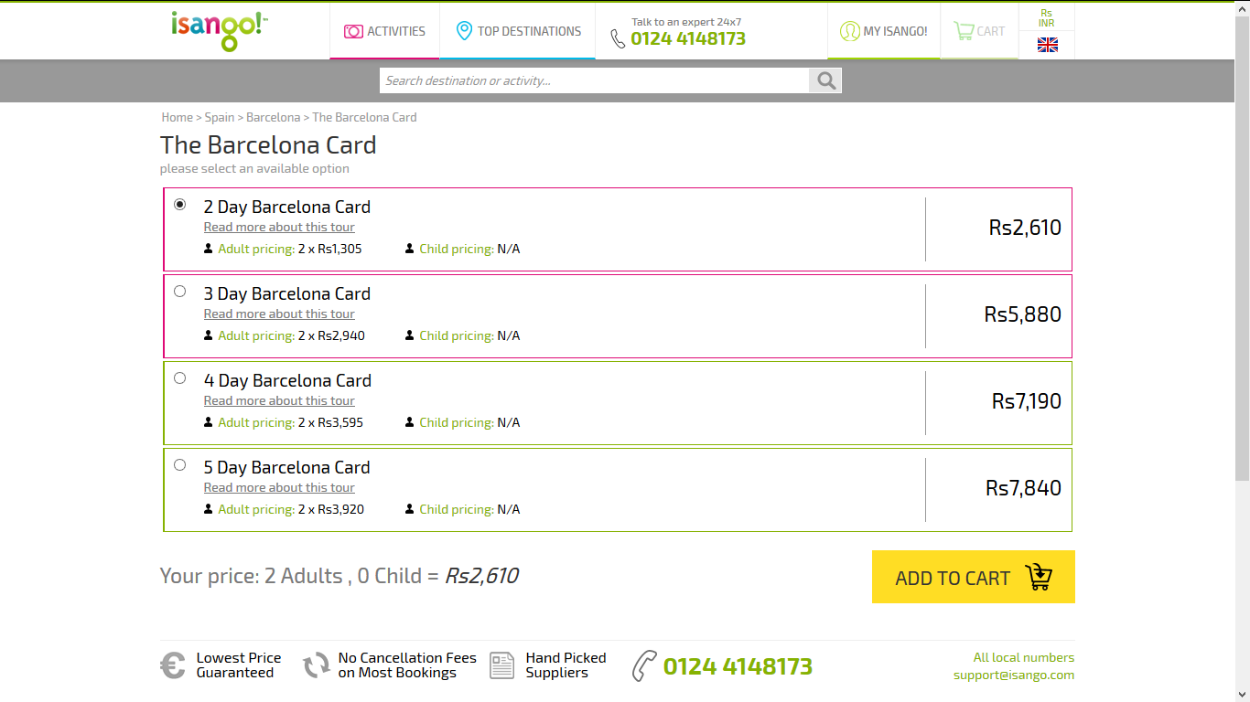

* Application displays available date options if selected product not available for selected date.

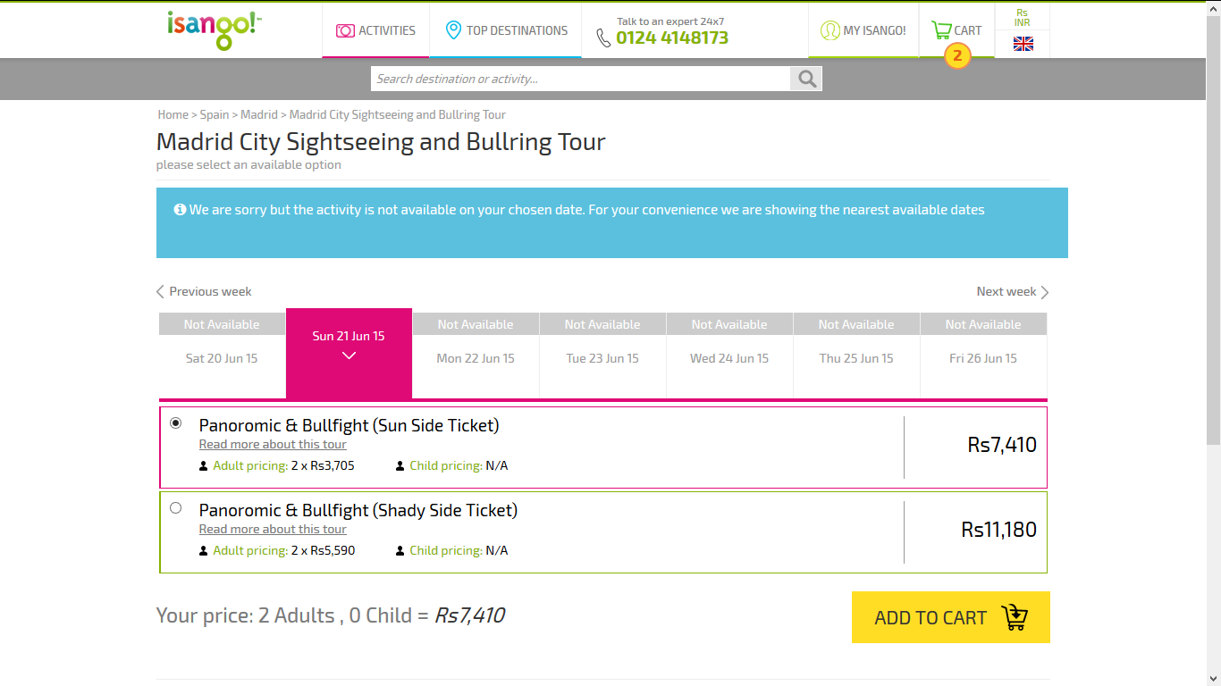

* Application does not display availability page for the products those don’t have options. For these type of product application displays cart page when user click on Check availability button on product detail page.

## 2.5. Cart Page

* Application display cart page when proceed using add to cart from availability page or when user fills all information in booking module of product page and clicks check availability button.

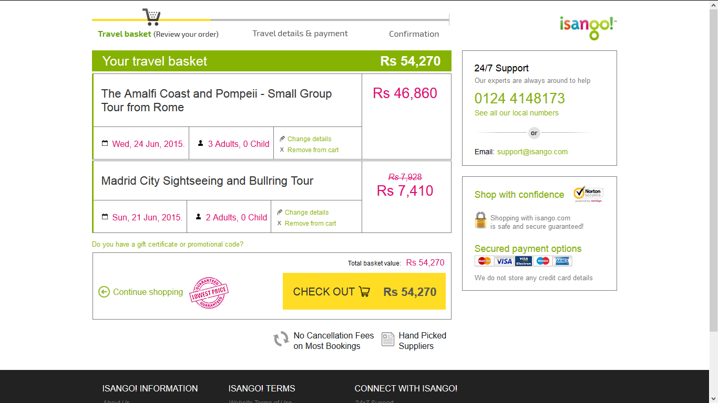

* Application displays all added product from product details page with travel detail information like: Date of travel, Number of child and Adults, Individual product price, Total cart price etc.
* Application also displays customer support information on cart page.

## 2.6. Payment Page

* Application displays payment page when user click on checkout button on cart page.
* Application displays field related to traveler’s information’s.
* Application also displays fields for payment process.
* Application has all mandatory fields and click on confirm booking.

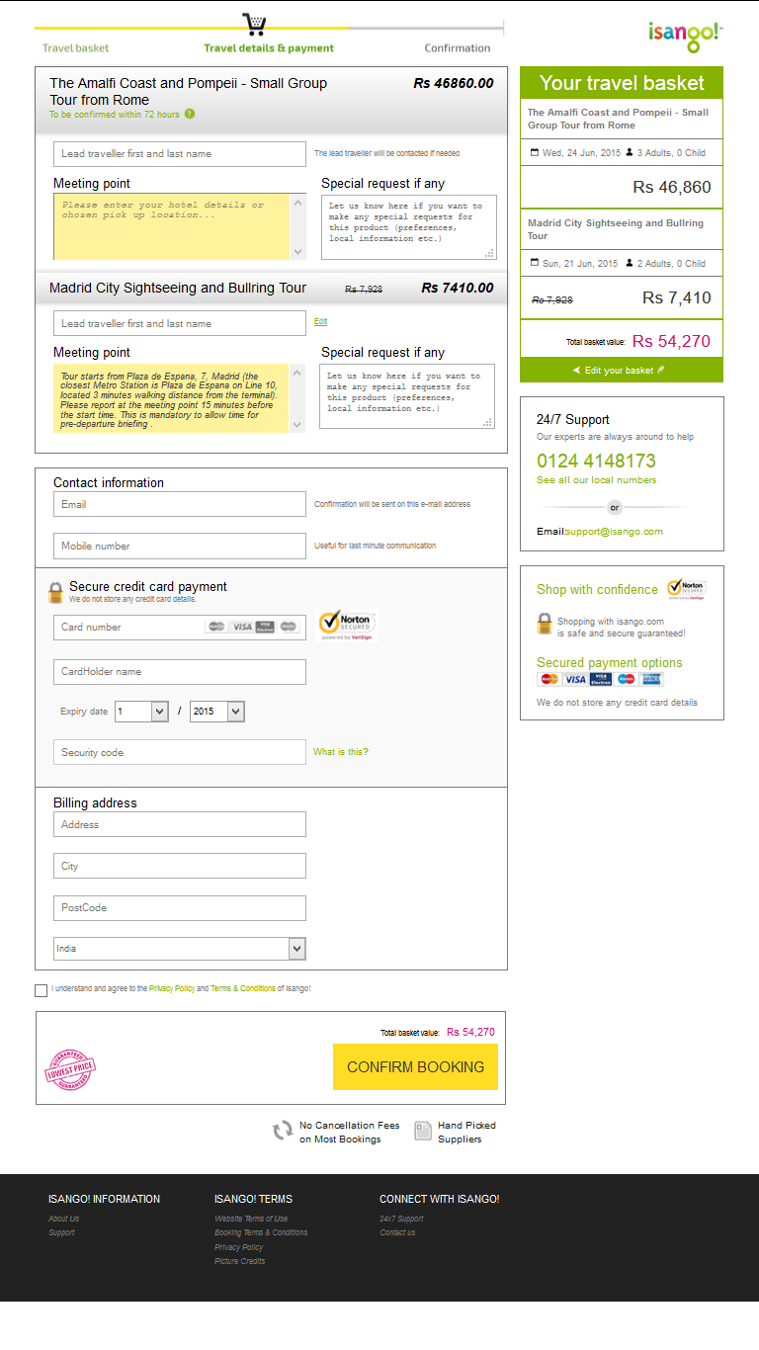

## 2.7. Confirmation Page.

* Application display confirmation page when user finally confirm booking from payment page.
* This page contains Booking reference number, Purchased product information and Pricing.

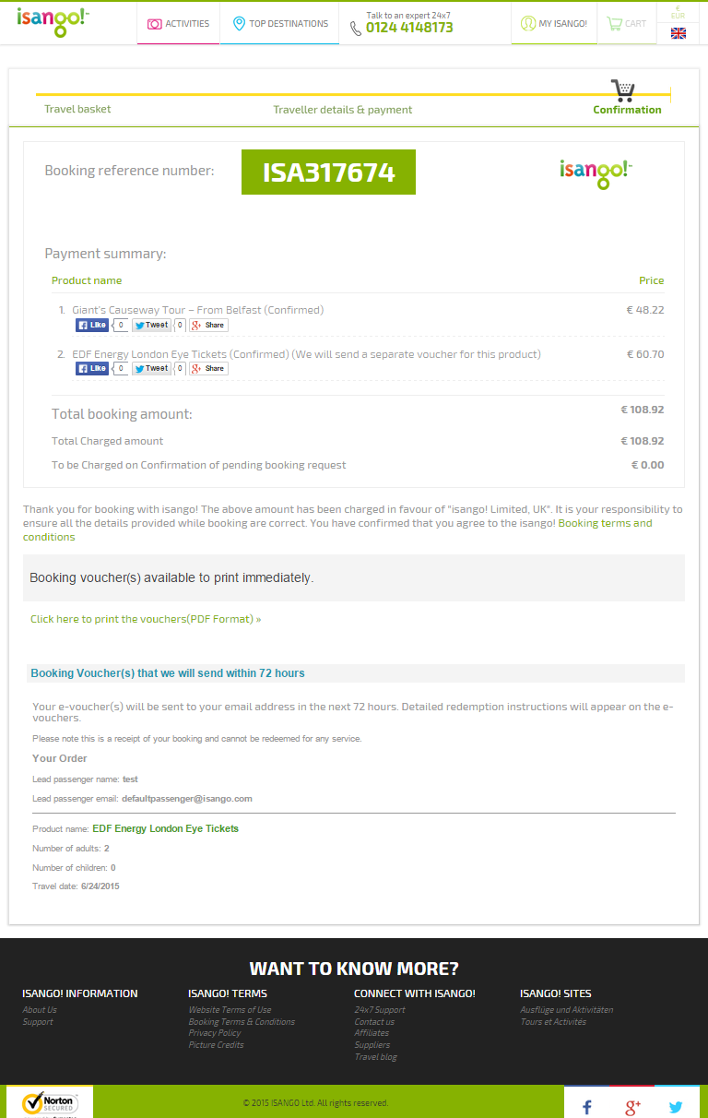

* Application also allows user to download the purchase voucher in PDF format.

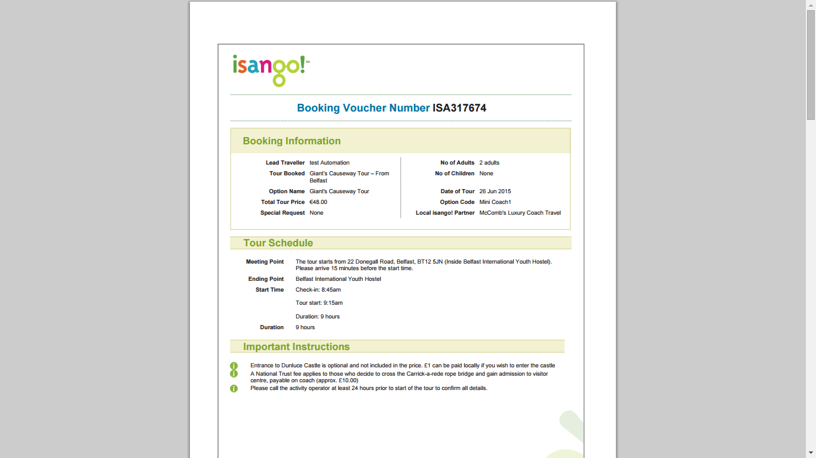

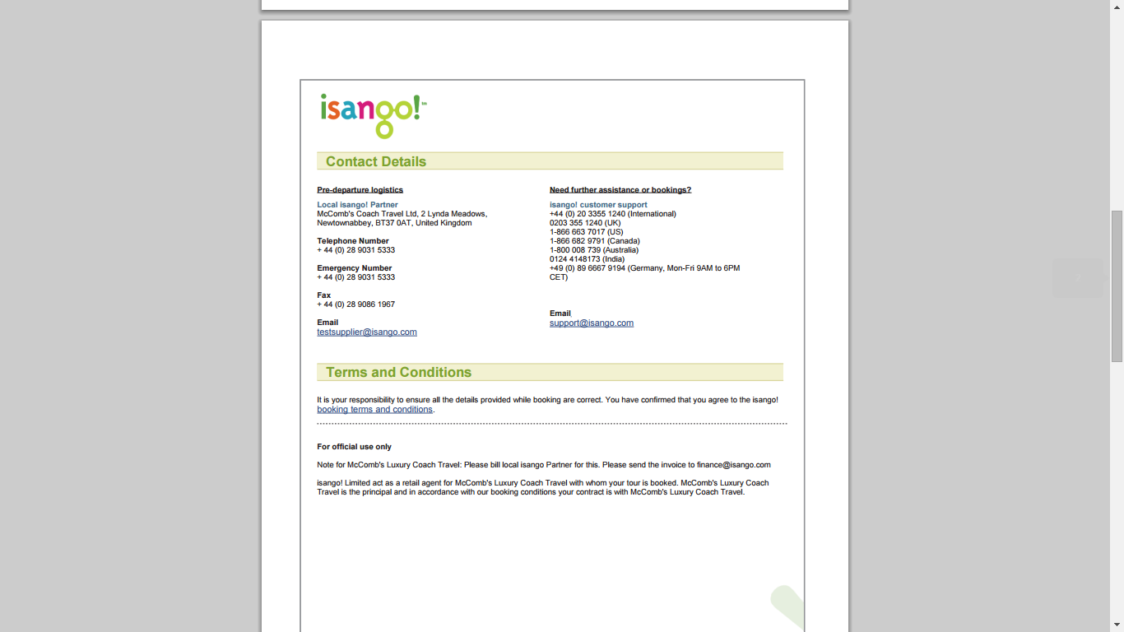

# 3.0 Type of Products available on Isango

There are wide range of products available for a user hit to Isango. Below mentioned are the product types

1. Extended Tours
2. Full Day Activities
3. Half Day Activities
4. Transfers & Others
5. Theatre Tickets
6. Theme Park

# 4.0 Supporting Information

Please refer the following document for more detailed information:

1. Smoke Test Cases
2. Regression Test Cases